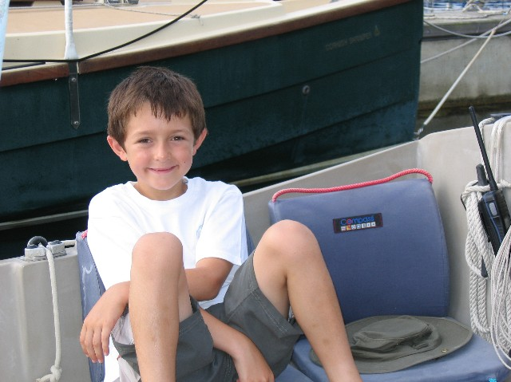
Normally the Spray (19) does not attend Solent Cruise Weeks as they usually fall outside of school holidays. This year was slightly different in that my school broke up on the Tuesday of the event. To my delight, Dad said we could go for 3 days. Late Tuesday night after I had come back from Beavers, Dad, me and my big brother Mike set off for Beaulieu. Mum had tried to persuade Dad that it would be a good idea to take our dog Bramble too. We boys were not convinced and said it would be better if Bramble looked after Mum.

We arrived at Beaulieu just before dark and during the journey Dad had been sure he had forgotten something. When I was told to put my lifejacket on, it dawned on him that it was still hanging in the conservatory some 1 hours drive away. We rose very early next morning to drive to Salisbury to meet Mum on her way to work to pick up the offending article. Then about turn back to Beaulieu.

After breakfast we motored down a windless foggy Beaulieu River and set a course for Hillhead. Dad later found out that everyone was heading for Cowes from Marchwood to go BBQ shopping on route to Island Harbour.

As the fog lifted with still little wind, we headed for Osborne Bay for lunch catching 4 magnificent mackerel on the way. We anchored in the bay and Dad set about gutting the fish and took great delight in showing me what they had for breakfast. With Spray (19) duly cleared of fish entrails and scales we went for a swim. I think Dad and Mike were impressed with my swimming as we swam to the shore where the ‘No Landing’ signs were. My Dad said it was okay to crawl out of the water onto the beach, you just were not allowed to jump off the boat and ‘land’ on it. I am not so sure. On our return we had a shower from the new shower bag dad bought in Mylor and then had lunch.

That afternoon we made our way up the Medina River to Island Harbour just about managing a sail from the Folly to the lock. It was good to see so many Shrimpers all together (and Mr Gus in his Golant Gaffer).
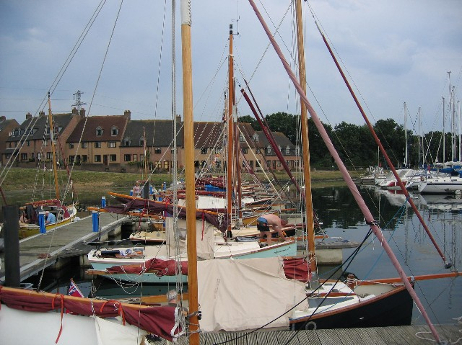
In the evening we had a BBQ and I met some of the Shrimpers I remember from before, Mr Rodney from the Winter cruise, Mr Clifford and Mr Tony from Old Gaffers at Yarmouth. I was impressed with the powerful hose pipe with the trigger on the jetty and was itching to have a go with it but Dad said we should conserve water.

Low and behold about half an hour later some of the ‘older’ Shrimpers were washing each other down with it !!

The next day we sailed up to Newtown Creek after a short stop in Cowes for some more ice for the icebox and more Coca Cola, to my delight. I think Dad took too much beer to Falmouth as there was still loads of tins under the bunks. No wonder he didn’t win any races. Anyway, we bought some more fishing tackle in the hope that we might catch some more mackerel. Tackle we duly lost trying to catch a 40 ft Halberg Rassey. Mike thought he had caught a whale but the line snapped and we realised what had caused it.

We anchored outside Newtown for a while to swim and cool down. We later entered the creek and anchored in company with Outrigger (676), Takamaka (817) and Gentle Breeze (786).
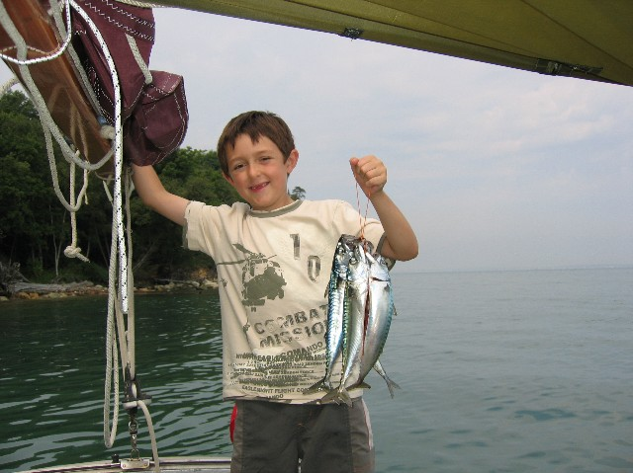
We played Uno before supper and after I had done the washing up we rowed to Shalfleet Quay for a walk to the New Inn. Dad must be losing it and truly becoming a true Shrimper owner because as we arrived at the quay he announced that he had forgotten his shoes. So he rowed back to the Spray (19) to get them. All good exercise for the old chap. Me and Mike did chuckle.

On our return at twilight we were fascinated by the display of swirling bats overhead. I was in charge of the torch during the row back until Dad explained to me about ‘night vision’ and battery conservation.

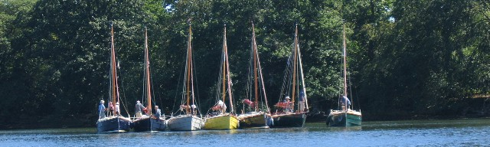
After breakfast the next morning we set sail for Beaulieu. Sailing really quickly with the tide. We anchored in the river for a while and then sailed up to the mooring to tidy up and put most of the gear in the car ready to go home.

We then had one last sail up to the top of the river passing the other Shrimpers anchored in Carpenters Reach. A great three days.

Fyn Mitchell aged 7.

